**Causation vs Correleation**

Issue in AI, with machine learning mainly just finding correlations (if I do this, this happens, or this data is connected to this data)

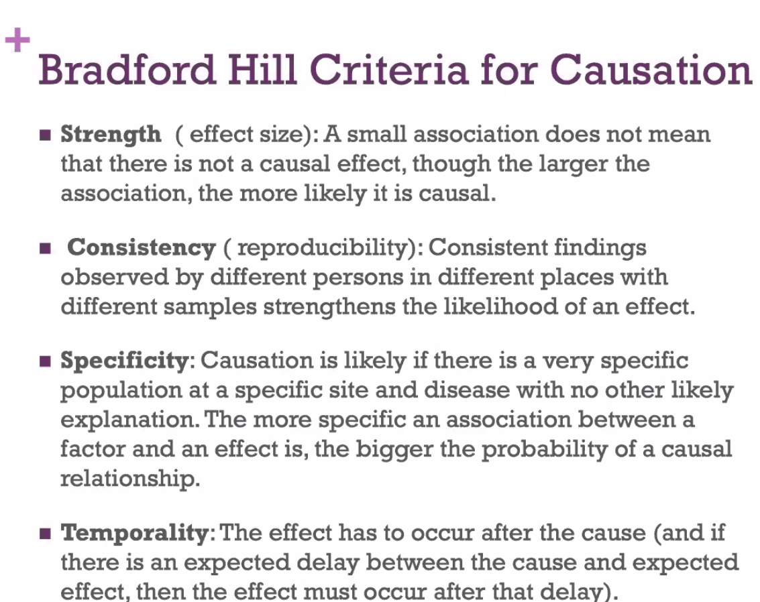

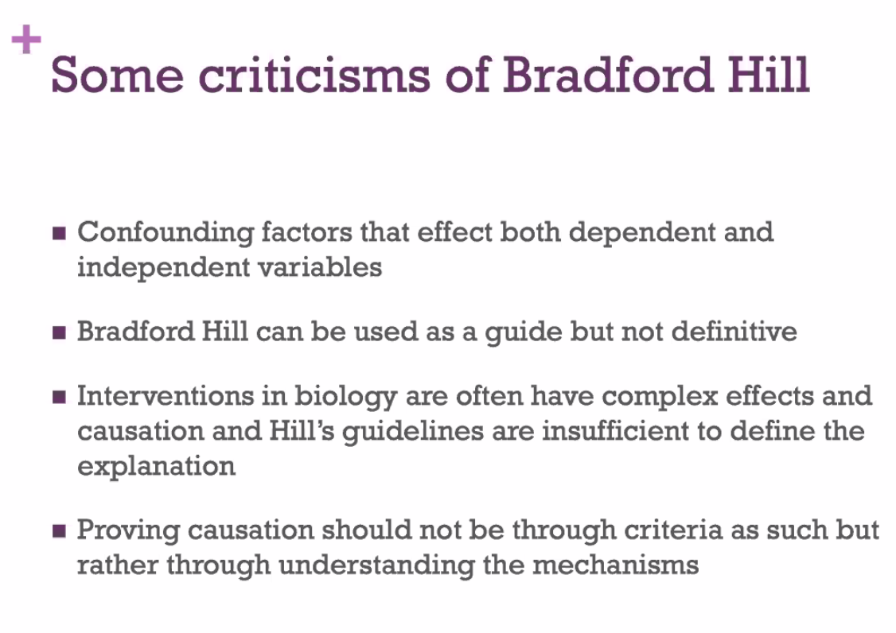

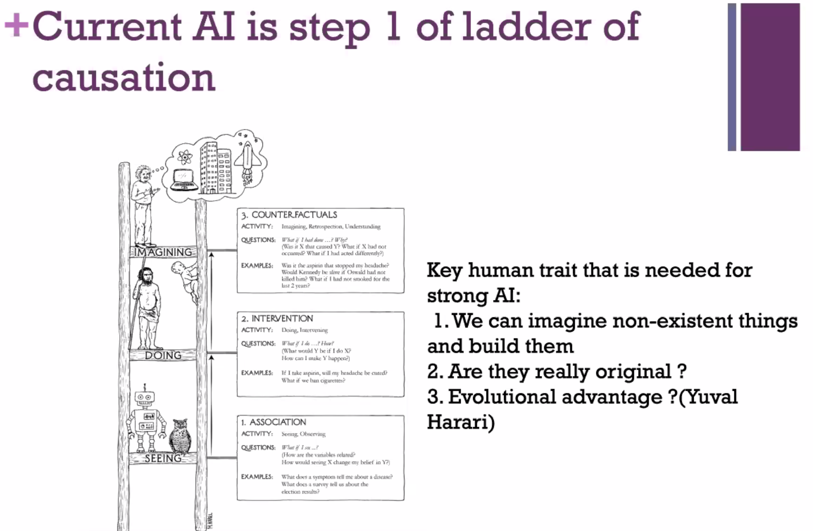

**Reinforcement Learning**

-Somewhere in between supervised and unsupervised learning

-see reward after attempt-adjust behaviour in each subsequent attempt

-trial and error with each attempt

-rather than training on existing data, data created through training

Imitation learning – goal is to replicate behaviour of others

-could have one example, or many

**General Adversarial Networks (GANs)**

-two competing networks

-way of developing creativity? -landscape paintings

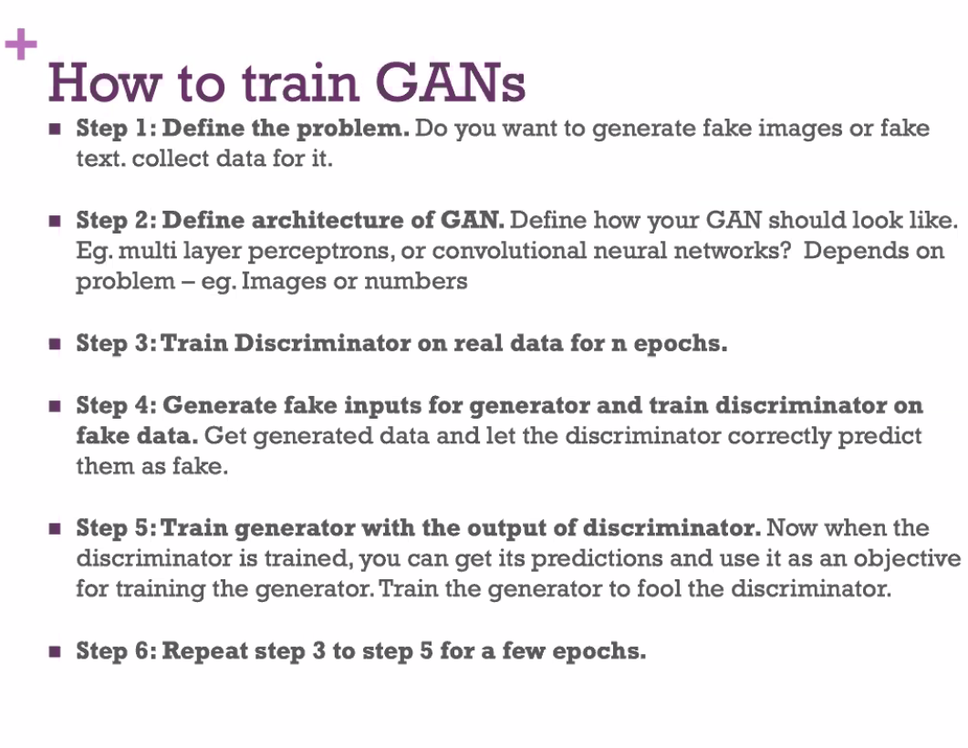

**End to end without feature processing**